1. Answer the questions following perceptron learning:

0.4

0.2

0.7

Input

Neurons

Output

Neuron

Weights

0.1

Bias

1

0

1

* 1. The input of the output neuron is: $$f\left(x\right)=bias+w_{1}x_{1}+w_{2}x_{2}+w_{3}x_{3} \\ f\left(x\right)=0.1+\left(0.4\right)\left(1.0\right)+(0.2)(0.0)+(0.7)(1.0) \\ f\left(x\right)=0.1+0.4+0.0+0.7=1.2$$
  2. If the transfer function of output neuron is ReLU, what is the output of output neuron?   
     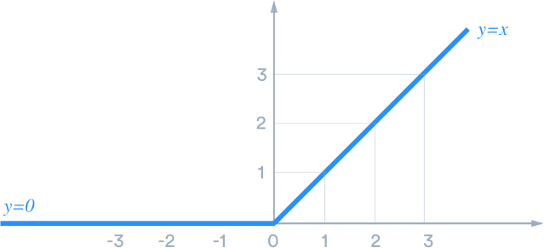
     1. The output of the output neuron, when using ReLU is 1.2, since $f\left(x\right)=\max\left(0,x\right)=\left\{\frac{y, ify>x}{x, otherwise}\right\}$  
         (By the way, I’ve never seen the max(0,x) form of this function before this class. It looks like a programming function call, not a mathematical function. This should have been explained in class.)
  3. If the desired output is 0 and the updating formula is given by   
     *wnew = wold +* α ×*(desired - output)* × *input*
     1. In NN’s terminology, what is α called?
        1. Alpha (α) is the learning rate or smoothing function.
     2. Suppose α=1, please update all weights.
 $$w_{new1}=w_{old}+α\left(desired-original\right)×input$$

 $w_{new1}=0.4+1\left(0-1.2\right)×1=0.4-1.2=-0.8$

$w_{new2}=0.2+1\left(0-1.2\right)×0=0.2-0.0=0.2$

$w_{new3}=0.7+1\left(0-1.2\right)×1=0.7-1.2=-0.5$

4. What is the output after you adjust all *w* for this round? $$f\left(x\right)=bias+w_{1}x_{1}+w_{2}x_{2}+w_{3}x_{3} \\ f\left(x\right)=0.1+\left(-0.8\right)\left(1.0\right)+(0.2)(0.0)+(-0.5)(1.0) \\ f\left(x\right)=0.1-0.8+0.0-0.5=-1.2$$ 
     The value -1.2 in the ReLU function results in y=0.

1. Please download default_credit.csv from BeachBoard, try to build:
   1. A decision tree classifier – HW4
   2. A random forest classifier – HW6
   3. A neuron network classifier – HW7, Pg 293

Requirements for Question 2:

* + - 1. Use 30% of the data as testing data
      2. Display the accuracy score of both training and testing data
      3. Please try to achieve at least >80% for the Neural Network

This data description is in <https://archive.ics.uci.edu/ml/datasets/default+of+credit+card+clients>

Note, in this dataset, the last column (Y ) is the class.

Hint: you better scale the input data before feeding to classifiers, like this:

from sklearn.preprocessing import MinMaxScaler

df = pd.read_csv('default_credit.csv')

X_df = df.drop(columns=['Y'])

y = df['Y']

scaleInput = MinMaxScaler()

X = scaleInput.fit_transform(X_df)